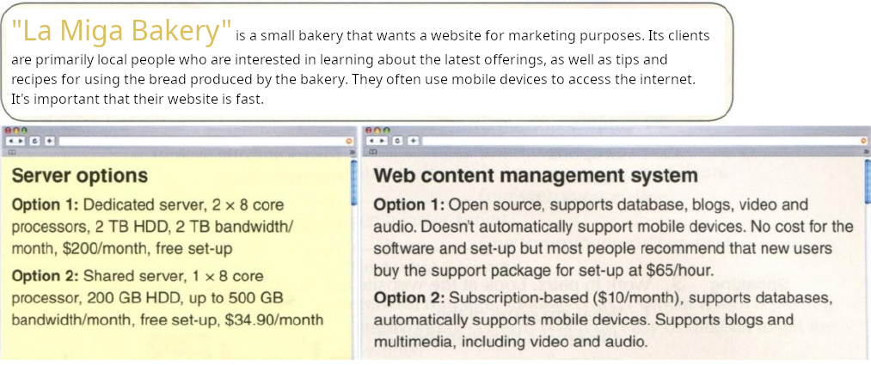

"La Miga Bakery" is a small bakery that wants a website for marketing purposes. Its clients are primarily local people who are interested in learning about the latest offerings, as well as tips and recipes for using the bread produced by the bakery. They often use mobile devices to access the internet. It's important that their website is fast.
"La Miga Bakery" will have the choice between two server options and two content management system (CMS) options.

In terms of servers, option 1 offers a dedicated server featuring 2 processors with 8 cores each, a 2 TB hard drive, 2 TB of monthly bandwidth, and free setup, priced at $200 per month. Option 2, on the other hand, provides a shared server with 1 processor of 8 cores, 200 GB of hard drive space, up to 500 GB of monthly bandwidth, and free setup, available at $34.90 per month.

For Content Management Systems (CMS), option 1 presents an open-source solution supporting databases, blogs, videos, and audio. However, it lacks automatic support for mobile devices. While there are no software costs, users may opt for a support package priced at $65 per hour for configuration assistance. Alternatively, option 2 offers a subscription-based system supporting databases, blogs, videos, and mobile devices.

I recommend selecting option 2 for both proposals for "La Miga Bakery." Opting for the shared server (option 2) over the dedicated server is primarily driven by its significantly lower cost, which is more suitable for the budget of a small bakery. Additionally, for the CMS option, choosing the subscription-based system (option 2) is advantageous as it ensures mobile device support, essential for engaging a wider audience and enhancing user experience in today's digital era. Moreover, the subscription model simplifies updates and maintenance without the need for additional support packages, making it a more convenient choice.

Juan Carlos Francisco Mesa.
2º DAW Semi A

